**Subject:** Logo and Banner Design Requirement for Website – Mazhar-e-Ala Hazrat

**Dear Team,** **As-Salaam-Alaikum Wa Rahmatullah,**

We hope this message reaches you in good health and high spirits during the blessed month of Safar.

We are currently seeking a professional designer to create a logo and banner images for our website: 🌐 www.mazhareaalahazrat.com

For thematic and visual guidance, here are some reference websites that reflect the Islamic aesthetic we aim to incorporate:

* alahazrat.net

**🎨 Logo Requirement**

* We previously created a logo using a mobile app, but we are not satisfied with the result. We are looking for a professionally designed logo that reflects the spiritual and cultural identity of our organization.
* 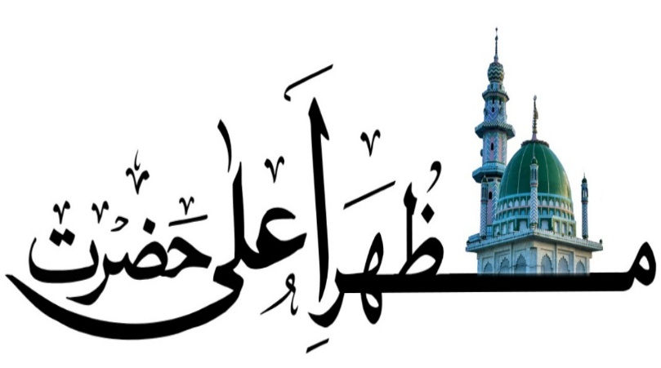

We created one logo through mobile but we are not stratified so ple

📸 **Image Requirements:**

We wish to include banner images that highlight key Islamic months and events, such as:

* Muharram
* Urs-e-Hashmati
* Urs-e-Razvi ...and other significant occasions throughout the Islamic calendar.

These images will be prominently displayed on the **landing page**, **home page**, and other key areas of our website to enhance spiritual engagement and visual appeal.

If you can provide sample designs or ideas that align with this vision, we would be happy to review them.

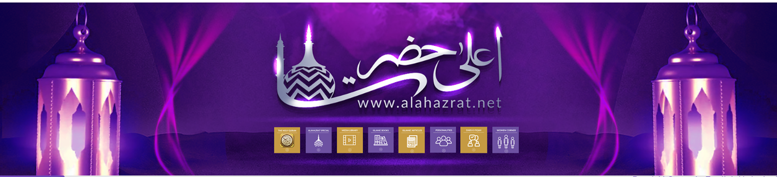

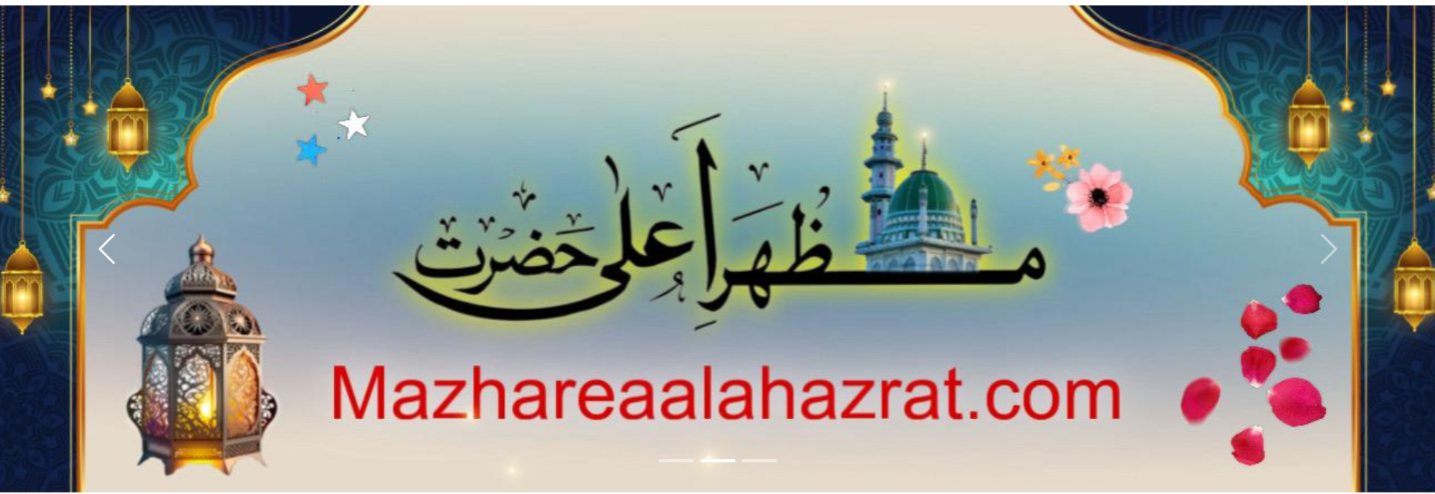

📌 *Please note*: We have not yet finalized the website theme. We welcome your suggestions, particularly those that reflect an authentic Islamic aesthetic and resonate with our audience.

We are trying to get the themes We are aiming to incorporate visual themes inspired by the Eid-e-Milad flag, particularly using the colors green, red, and white. These colors will guide the design aesthetics throughout the website to reflect the spiritual essence and cultural identity of the occasion.below eid e milad flag ( Green , Red and white )

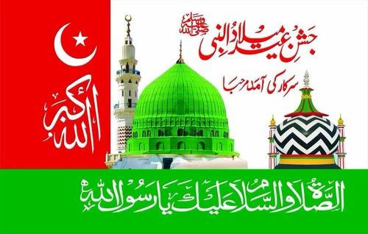

If you have portfolio samples or theme ideas tailored for Islamic organizations, we would love to review them.

**JazakAllah Khair.**

Khan